**EXPERIMENT NUMBER –9**

**Student Name: Shinde Smita Shahaji UID: 20BCS4643**

**Branch: CSE (IOT) Section/Group: IOT (Group-B)**

**Semester: 2nd semester Date of Performance:04/30/2021**

**Subject Name: Quantum and Semiconductor physics lab**

The velocity of ultrasonic sound through water media.

AIM OF THE EXPERIMENT –

To calculate the velocity of ultrasonic sound through water media.

APPARATUS-

|  |  |  |  |
| --- | --- | --- | --- |
| Sr.No. | Equipment | Range | Quantity |
| 1. | Ultrasonic interferometer | 2MHz | 1 |
| 2. | Sample liquids | 20ml | 1 |
| 3. | Power supply | 220V | 1 |

Diagram

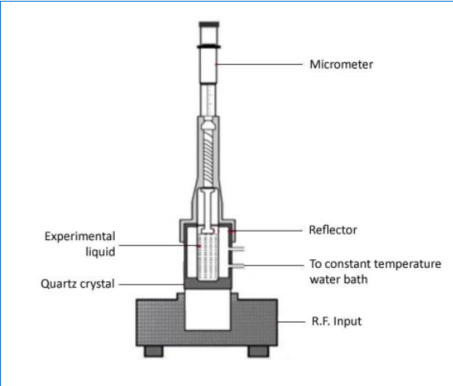

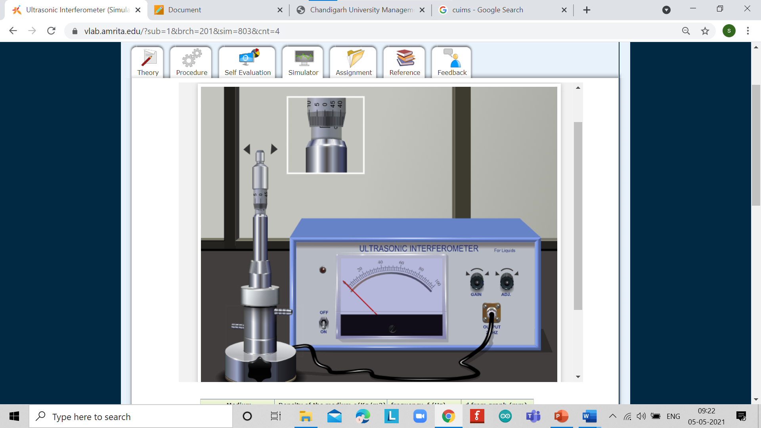

Formula used

* If *d* is the separation between successive adjacent maxima of anode current, then,

 d = $\frac{\text{λ}}{2}$

* We have, the velocity (*v*) of a wave is related to its wavelength (λ) by the relation,

v= λ f where f is the frequency of wave.

* Then,

v= λ f = 2df

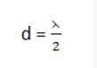 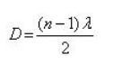 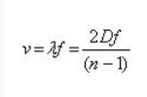

OBSERVATIONS-

1.Least count on main scale= 0.5 mm

2.Pitch of circular scale= 0.5

3.Least count of screw gauge= Pitch/no. of divisions on circular scale

= 0.5/50

= 0.01 mm

4.Frequency of the ultrasound used (f) = 3 MHz

5.Medium used= Acetone

Density of water, = 790 Kg/m3

|  |  |  |
| --- | --- | --- |
| Sr.No. | Micrometer Reading Corresponding to maxima/minima (mm) | Difference between consecutive Maxima/Minima d=λ/2 (mm) |
| 1. | 0.18 | 0.36 |
| 2. | 0.54 | 0.36 |
| 3. | 0.90 | 0.36 |
| 4. | 1.26 | 0.36 |
| 5. | 1.62 | 0.36 |
| 6. | 1.98 | 0.36 |
| 7. | 2.34 | 0.36 |
| 8. | 2.70 | 0.36 |
| 9. | 3.06 | 0.36 |
| 10. | 3.42 | 0.36 |

Mean d=0.36

The velocity of ultrasonic waves is calculated as v=λ *f*=2df = 2160 ms-1

Standard velocity of ultrasonic waves is = 1203 m/s

CALCULATIONS-

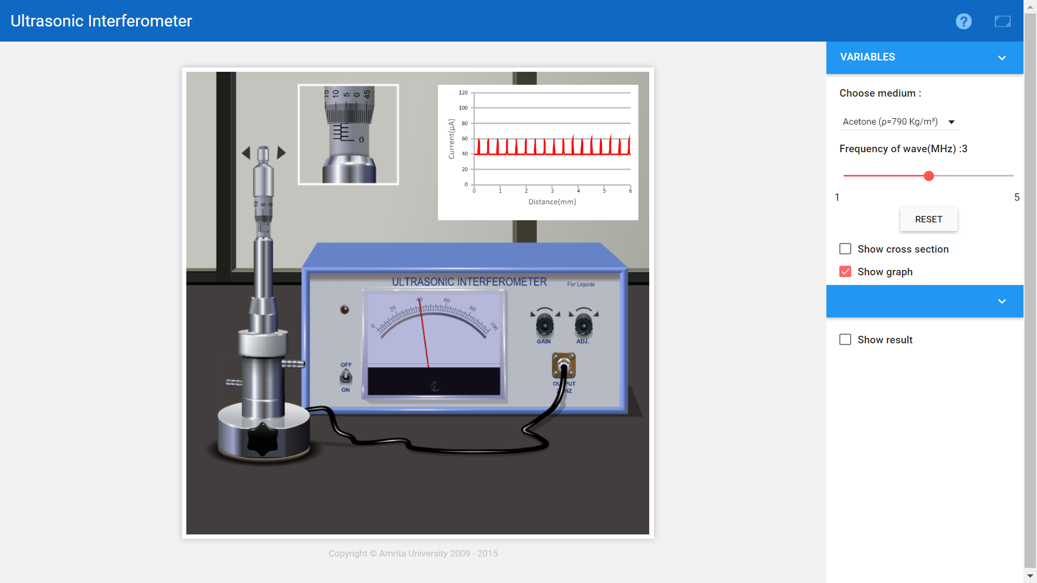

PERCENTAGE ERROR-

No any percentage error

GRAPH (ATTACH IF ANY)-

SOURCES OF ERROR-

No any sources error

RESULTS AND DISCUSSION-

Result: -

The velocity of the ultrasonic wave through the given liquid medium = 2160 ms-1.

Conclusion

In conclusion, Ultrasonic waves move with a very high speed. That is why, the standard velocity of ultrasonic waves is =1203 m/s

LEARNING OUTCOMES

|  |
| --- |
| * It will provide the modest experience that allows students to develop and improve their experimental skills and develop ability to analyze data. |
| * Ability to demonstrate the practical skill on measurements and instrumentation techniques of some Physics experiments. Students will develop the ability to use appropriate physical concepts to obtain quantitative solutions to problems in physics. |
| * Students will demonstrate basic experimental skills by setting up laboratory equipment safely and efficiently, plan and carry out experimental procedures, and report verbally and in written language the results of the experiment. |
| * Students will develop skills by the practice of setting up and conducting an experiment with due regards to minimizing   measurement error. |

EVALUATION COLUMN (To be filled by concerned faculty only)

|  |  |  |  |
| --- | --- | --- | --- |
| **Sr. No.** | **Parameters** | **Maximum Marks** | **Marks Obtained** |
| 1. | Worksheet completion including writing learning objectives/Outcomes. (To be submitted at the end of the day) | 10 |  |
| 2. | Post Lab Quiz Result. | 5 |  |
| 3. | Student Engagement in Simulation/Demonstration/Performance and Controls/Pre-Lab Questions. | 5 |  |
| 4. | Total Marks | 20 |  |
| 5. | Teacher’s Signature (with date) |  | |